NSF Biographical Sketch
Last updated: January 30, 2023

For proposals submitted or due on or after January 30, 2023, an updated Biosketch must be used to comply with the NSF Proposal & Award Policies & Procedures Guidelines (PAPPG 23-1).

A separate biographical sketch (limited to three pages) must be provided in one of NSF’s two approved formats for each individual identified as Senior Personnel. Specific NSF funding solicitations may require or permit Biosketches to be submitted for individuals other than Senior Personnel; please refer to the solicitation instructions for additional guidance.
- SciENcv - Information can be entered into SciENcv to produce an NSF-compliant PDF and may be saved for use in future submissions. Proposers must save the PDF locally and submit them as part of their proposal submissions via Research.gov (preferred) or Grants.gov.

- NSF Fillable PDF (available for use through October 22, 2023*) - NSF provides a fillable PDF for use in preparation of the biographical sketch. Proposers should download a local copy of the PDF to their computer and once completed, upload the certified form (See the Certification section below) as part of their proposal submissions via Research.gov (preferred) or Grants.gov.
*As of October 23, 2023, SciENcv will become the only format allowed for Biosketch preparation; the fillable PDF form will be retired on October 22. NSF strongly encourages early adoption of SciENcv in advance of the October 23 transition date.
The following information must be provided for each Senior Person in the order and format specified below. Inclusion of additional information may result in the proposal being returned without review.
(1) Identifying Information
  - Name, ORCID ID (optional; see https://orcid.org/ for more information), Current Position Title

(2) Primary Organization and Location
- Name of individual’s primary organization and its location (city, state/province, and country)

(3) Professional Preparation (see PAPPG Chapter II.D.2.h(i)(a)(3))
- List undergraduate and graduate education and postdoctoral organizations and their locations in reverse chronological order by start date, beginning with the most recent training/educational experience.

- For each entry, provide:
  - Name of organization and its location - city, state/province (if applicable) and country
  - Degree received (if applicable)
  - Month and year (in MM/YYYY format) the degree was received or is expected
  - Field of Study

- For fellowship applicants only, please include the start date of the fellowship

(4) Appointments and Positions (see PAPPG Chapter II.D.2.h(i)(a)(4))
- List all academic, professional, or institutional appointments and positions in reverse chronological order by start date, beginning with the current appointment(s)

- Appointments and positions include any titled academic, professional, or institutional position whether paid or unpaid, full- or part-time, or voluntary (including adjunct, visiting, or honorary positions.

- For each entry, provide:
  - Start Date and End Date
  - Appointment or Position Title, Organization, and Location (city, state/province, and country)

(5) Products (see PAPPG Chapter II.D.2.h(i)(a)(5))

- List up to five (5) publications/products most closely related to the proposed project
- List up to five (5) other significant publications/products, whether related to the proposed project

Acceptable products must be citable and accessible, including but not limited to:
- Publications, conference papers, and presentations
- Technologies or techniques
- Inventions, patent applications, licenses, copyrights
- Data sets, databases, websites, physical collections, audio/video products, software

Required Citation Format:
- Names of authors (“et al” may be used in lieu of including complete list of authors’ names)
- Product title
- Website URL or other persistent identifier, if available
- Other relevant citation information (e.g. for publications, list title of journal/book, volume, issue, pages)

(6) Synergistic Activities (see PAPPG Chapter II.D.2.h.(i)(a)(6))
- List up to five (5) distinct examples that demonstrate the broader impact of the individual’s professional and scholarly activities that focuses on the integration and transfer of knowledge as well as its creation
- Examples may include:
  - Innovations in teaching and training; contributions to the science of learning
  - Development and/or refinement of research tools
  - Computation methodologies and algorithms for problem-solving
  - Development of databases to support research and education
  - Broadening the participation of group underrepresented in STEM
  - Service to the scientific and engineering community outside of the individual’s organization

Sample Synergistic Activities format:
- Co-Chaired 2021 Academic Conference (specify organization and/or conference name)
- Member of the National Academy of Sciences (2017-present)
- Served as NIH Peer Reviewer (2016-2018)
- Organized summer workshop to deliver training to undergraduates interested in research (2022)
- Editorial board member of Academic Journal (2017-2021) (specify name of journal/publication)

Synergistic activities should be specific and must not include multiple examples to further describe the activity. Examples with multiple components, such as committee member lists, sub-bulleted highlights of honors and prizes, or a listing of organizations for which the individual has served as a reviewer, are not permitted.

(7) Certification (see PAPPG Chapter II.D.2.h.(i)(a)(7)) **NEW**

Effective on January 30, 2023, both the SciENcv and the PDF fillable versions of the Biosketch will require each Senior Person to certify that the information on their Biosketch is current, accurate, and complete.

To certify a Biosketch in SciENcv:
Once the document has been prepared, the Senior Person will download it as a PDF and be prompted to agree with the following certification statement, which will be printed at the end of the PDF with their name and a date/time stamp:

When the individual signs the certification on behalf of themselves, they are certifying that the information is current, accurate, and complete. This includes, but is not limited to, information related to domestic and foreign appointments and positions. Misrepresentations and/or omissions may be subject to prosecution and liability pursuant to, but not limited to, 18 U.S.C. §§287, 1001, 1031 and 31 U.S.C. §§3729-3733 and 3802

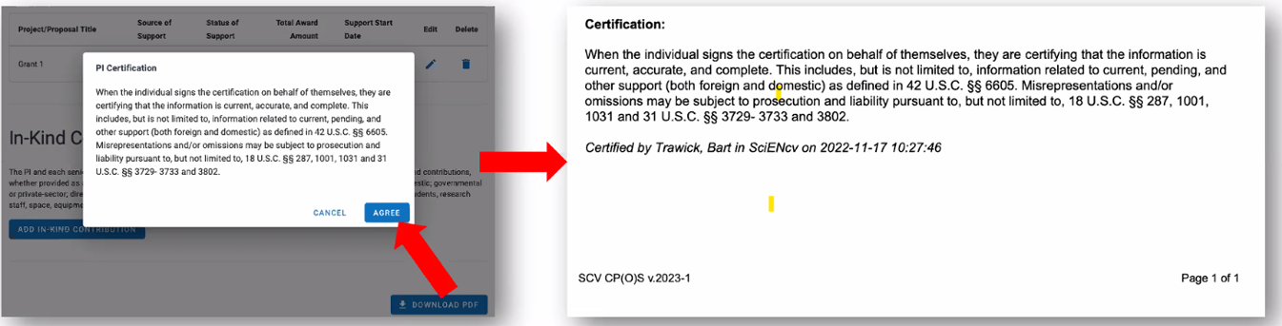

To certify a Biosketch in the fillable PDF format:

The Senior Person will type their full name and the date they completed the Biosketch in the Signature and Date fields that appear at the end of the document to indicate their agreement with the certification statement:

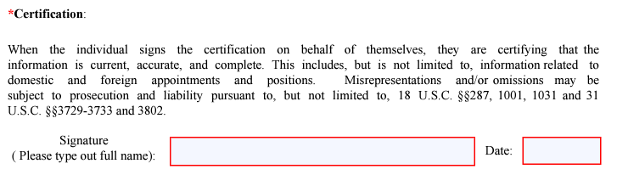

Additional Instructions for Other Personnel (i.e. individuals not classified as Senior Personnel)
Proposals may include information on the exceptional qualifications of Postdoctoral Associates, Other Professionals, and Students (Research Assistants) that merit consideration in the evaluation of the proposal.

While use of an NSF-approved format for the biographical sketch is required for Senior Personnel, biographical information for “Other Personnel” may be freeform. Such information should be clearly identified as “Other Personnel” biographical information and uploaded as a single PDF file in the Other Supplementary Documents section of the proposal.

Additional Instructions for Equipment Proposals
For equipment proposals, the following must be provided for each auxiliary user:

(a) Short biographical sketch; and
(b) List of up to five publications most closely related to the proposed acquisition.

Such information should be clearly identified as "Equipment Proposal" biographical information and uploaded as a single PDF file in the Other Supplementary Documents section of the proposal.

